In order to develop a mathematical model of a single rotor helicopter (at least one which is within the scope of this class) quite a few assumptions must be made:

* The lift curve slope is assumed to be two dimensional and constant
* The fluid (air) is assumed to be incompressible
* Stall and reversed flow effects are ignored
* The induced velocity distribution, normal to the rotor disc, includes linear longitudinal and lateral variations, the value at the center satisfying simple momentum considerations.
* Coupling from blade pitch and lag dynamics into flapping motion are ignored
* Quasi-steady flapping and coning are used in the derivation of the reaction forces and moments on the fuselage. i.e. the interaction of disc tilt modes with fuselage mode are neglected.

Controlling a helicopter is a complicated and intricate task, with a total of 6 degrees of freedom encompassing linear movement in the x,y and z directions along with roll, pitch and yaw movements.

For the sake of time and scope of, not all of the degrees of freedom will be included in the control system. A simplified block diagram of the Plant is shown below with inputs shown coming in from the left, and outputs leaving to the right.

**Inputs**

$ω_{f}$

­

PLANT

$$Q_{E}$$

ϴo­

FL

**Outputs**

Where:

$ω_{f}$ =Fuel Flow

Q­E=Engine torque

Ω=Rotational speed of the rotor

FL=Lift force generated by the rotor blades

Another important aspect in the preliminary stages of designing a controller is to determine the equations that relate the inputs to the outputs, or the “PLANT”. For the simplified model of the helicopter (or the PLANT), the equations relating the input to the output are as follows [2]:

${\ddot{Q}}_{E}=\frac{1}{τ_{e1}τ_{e2}}\left\{-\left(τ_{e1}+τ_{e3}\right){\dot{Q}}_{E}-Q_{E}+K_{3}\left(Ω-Ω_{i}+τ_{2}\dot{Ω}\right)\right\}$**(1)**

$$Q_{E}-Engine Torque$$

$$Ω-Rotational Speed of rotor$$

$$Ω_{i}-Idle speed of rotor$$

$$τ_{e1} \& τ_{e3}-time constants concerning fuel flow rate$$

$$K_{3}-Is a gain with respect to maximum engine torque$$

$\dot{Ω}=\frac{1}{I_{R}}\left(Q_{E}-Q_{R}-G_{T}Q_{T}\right)+\dot{r}$

$$I_{R}-Moment of inertia for rotating system$$

$$Q_{E}-main engine torque$$

$$Q_{R}-Main rotor torque$$

$$Q_{T}-Tail rotor torque$$

$$G_{T}-Gear ratio for tail rotor$$

$$\dot{r}≡\frac{∂}{∂t}\left(r\right)-rate of change of roll of system w.r.t. time$$

For the system at hand, the tail rotor torque will be assumed to be constant (possibly zero), as well as, the roll of the system.

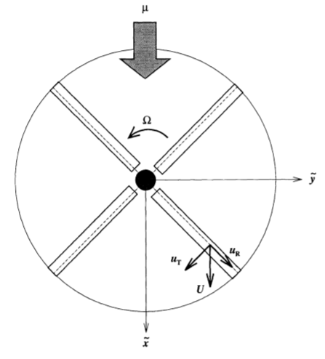

Figure -Diagram showing rotor rotation [1]

$F_{L}=\frac{1}{2}ρu_{T}^{2}{\left(ΩR\right)}^{2}\left(a*alpha\right)$ (2)

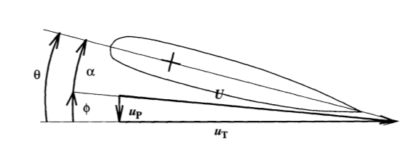

Figure 2-Diagram showing the relationship between angle of attack and pitch angle [1]

$$ρ-density of air at STP$$

$$u_{T}-horizontal distance of right triangle formed from pitch angle$$

$$Ω-Rotor rotation speed$$

$$R=Rotor radius$$

$$alpha-Angle of attack$$

$$a-slope of approximated linear sectional lift coefficient (c_{L})$$

**Actuators and Sensors**

For inputs and outputs to change, and be controlled a way to convert mechanical energy to electrical energy and back to mechanical energy must be implemented, along with some way to measure the actuated objects. For a helicopter system, a common way to control the torque of the engine is through a twistable handle (the throttle) located on the main joy stick which also controls the collective pitch of the rotor blades. Once a command is given, the resulting changes must be measured and fed into the control system. Here, the speed of the rotor shaft will be measured, and a torque will be back calculated. For the lift force (FL), an accelerometer can be placed on the hub and the collective pitch will be adjusted until a desired lift force is achieved.

**Conclusion**

Many intermediate equations will be needed to arrive at the final output values, but this is only a starting block with the inputs, outputs and main plant equations being the objects of focus. Depending on the ease and success of developing and controlling the above system, complexities may be added but at this point in time it will meet the minimum requirement of a MIMO system with two inputs and two outputs.

**References**

1. Garcia,J.C., (1994). “Active Helicopter Rotor Control Using Blade-Mounted Actuators”.

Mechanical Engineering Department Massachusetts Institute of Technology.

1. Thanapalan, K.K.T, “Modeling of a Helicopter System”. Faculty of Engineering Sciences,

University College London